Switching to a Local Database
We are getting some instances of Azure accounts expiring. Not clear why this should be so but given the looming deadline it is probably a good idea to give some instructions on how to set up a local database file.

GitHub does not respond well to this configuration so by following these instructions you will not be able to merge your database into the master branch.

Creating the Folder Structure

With Visual Studio closed open the folder structure for your system.

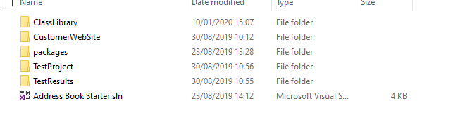
On the same level as your project folders create a new folder called App_Data like so…

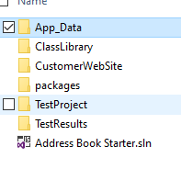

Now open your project in Visual Studio.

So far in the module you have been using the SQL server object explorer.

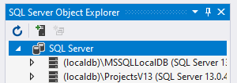

For this configuration you will be using a similar tool the server explorer…

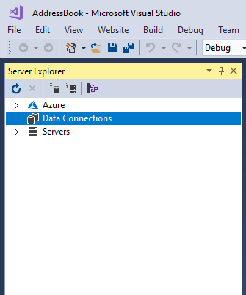

If you cannot see it go to View – Server Explorer to make it visible…

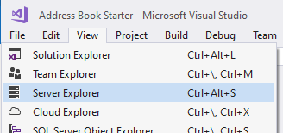

Click on the button Connect to Database...

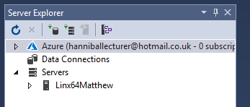

You should see the following dialogue box.

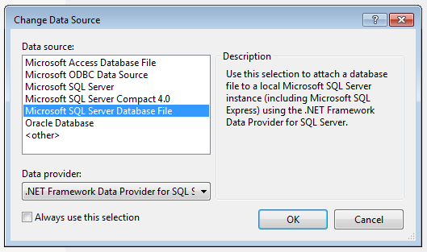

Select “Microsoft SQL Server Database File and press OK.

You should next see the following screen...

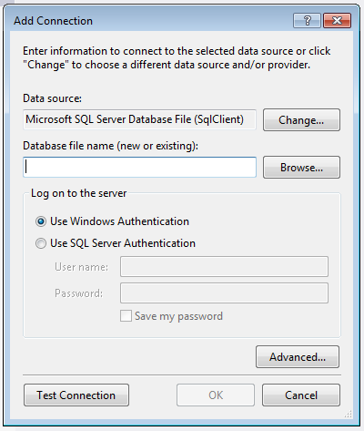

Click on Browse and navigate to the App_Data folder you created above...

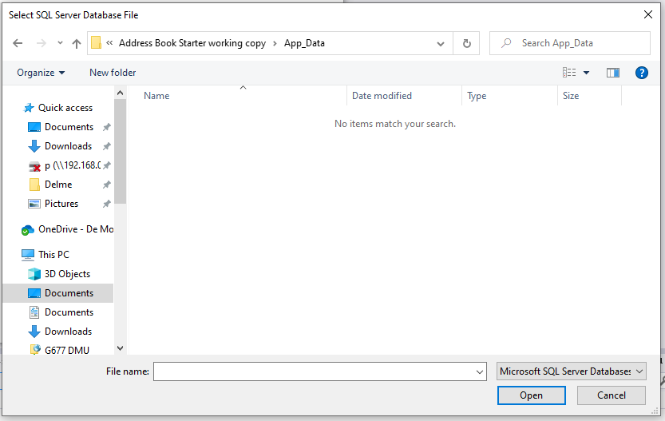

Type the name of the database file you want to create, in my case AddressBook.mdf…

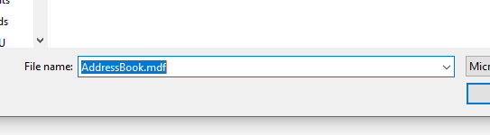

Press Open.

On the next screen press OK

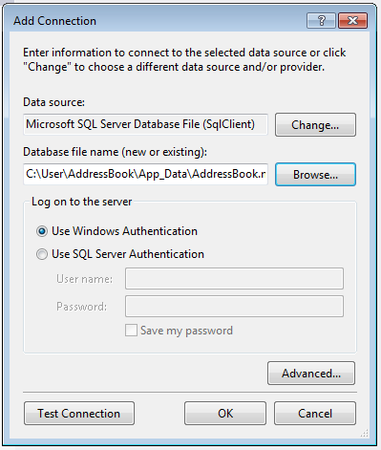

Visual Studio should now ask if you want to create the database file...

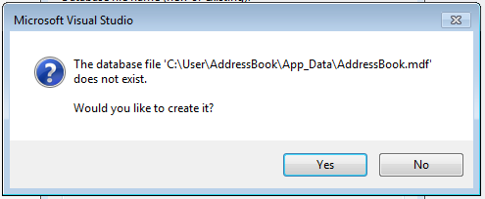

You should also be able to access it via the server explorer on the left of the program...

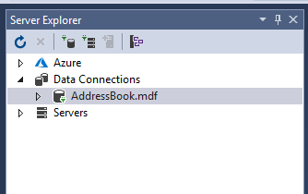

The interface for the server explorer is very similar to the object explorer.

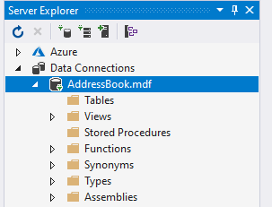

Remember that this is a local install of the database so any data will not be shared with other team members.

Updating the Data Connection

Now that you have created the database file you will need to update the code for the data connection so that it can access the local file.

At the module web site go to the link for the data connection…

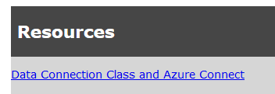

On the next page access the code for the SQL Server Dataconnection

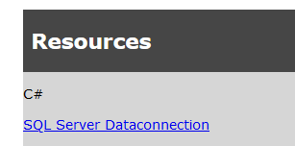

Copy all of this code and replace the code in your existing clsDataConnection…

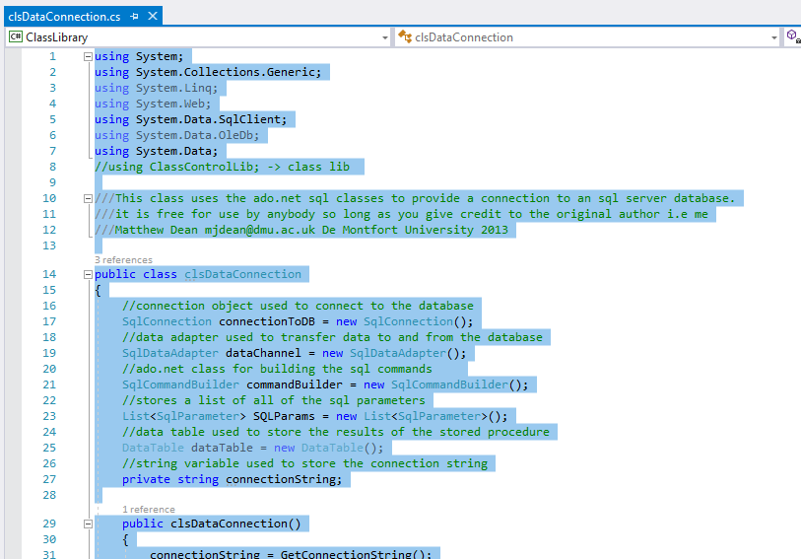

Close and save the file.

You will need to re-create your table and your stored procedures using your backup from Azure.

Once this is set up you will not need to use Azure Connect or your Azure credentials to connect to the local database.

Having replaced the data layer your code should still work exactly as it did when linked to Azure, the most likely errors are going to be typos in recreating your table and stored procedure or missing test data in your table data.

